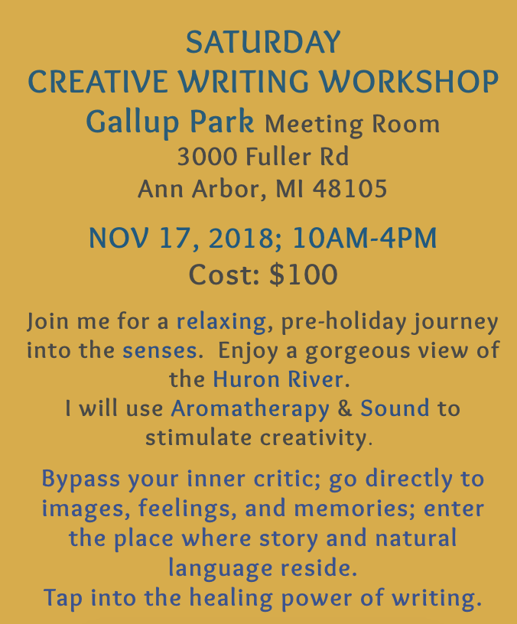
Texts I will use to prepare for the workshop:
Writing the Natural Way by Gabriele Rico
A Natural History of the Senses by Diane Ackerman
The Writer’s Journey by Christopher Vogler
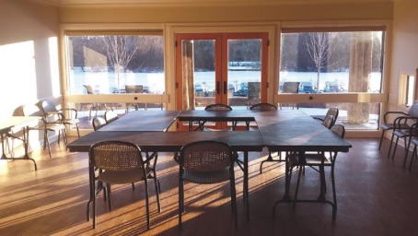
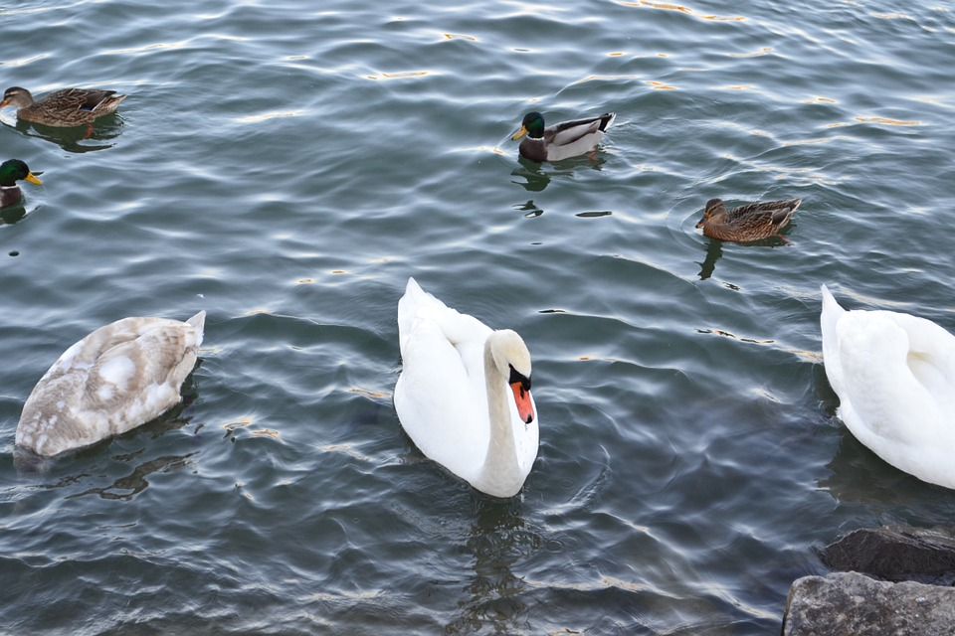
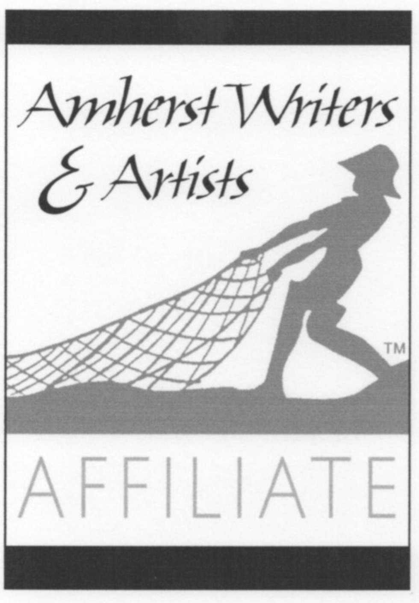
The Journey from the Center to the Page:Yoga Philosophies & Practices as Muse for Authentic Writing by Jeff Davis

Beginners & Experienced Writers Welcome
Uses the Amherst Writers & Artists workshop method

